Micro ChIP assay – Dahl & Collas, Nat Protocols, 2008.
http://www.nature.com/nprot/journal/v3/n6/full/nprot.2008.68.html

1. Cell Collection/Fixation
Collection
-Remove media from cell plates
-Wash twice with sterile PBS
-Remove PBS and add trypsin to each plate (4ml for 100mm, 6ml for 150mm dishes…)
-Place cell plates in incubator for 5 mins and then check to see if all of the cells are floating
-if not, return to incubator and keep checking at 2 minute intervals
-Once all cells are floating, add an equal amount of media to each plate
-Collect all like cells/media/trypsin into labeled tubes.

Cell Counting (Recommended Method)
-Place 10 ul of sample onto the counting slide (hemocytometer) with cover slip on.
-Count cells in each of the 5 quadrants (see schematics).
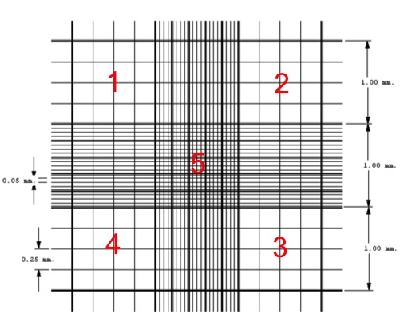

$Counting in 5 quadrans X {2.10}^{3}=C × {10}^{6}cells/ml$

$Total nb of cells=C.{10}^{6 }X x ml (vol in which cells are collected)$

-Spin cells 2000g for 5 min 4C. Resuspend in PBS and calculate volume to add to get 10^6 cells/ml based on calculations. Aliquot in 1.5ml eppendorf tube, 1ml (1 million cells) per tube.
-Repeat wash with PBS. Resuspend in adequate volume of PBS. Spin 2000g, 5 min, 4C.

RNA isolation
It is highly recommended to keep some of the cells harvested as detailed above for gene expression quantification by real-time PCR. Take one aliquot (one million cells) for each condition/plate harvested previously to allow side comparison between ChIP and gene expression results. This can also allow you to validate the efficiency of a treatment (e.g. PDGF-BB) prior to perform ChIP or ChIP-seq experiments.

-Take one aliquot after centrifugation and remove PBS.
-Add 500 ul Trizol in the fume hood then place tubes at -80c until isolation.

Cell fixation
-Remove PBS, leaving the pellet.
-Prepare 20mM Na-butyrate PBS: 980ul PBS + 20 ul 1M Na-butyrate per mL (+1mM PMSF and 1X protease inhibitor mix final)
-Put 500 ul of 20mM Na-butyrate PBS into each tube
-Add 31.25 ul PFA (16% initial concentration. 1% final concentration)
-let sit 10 min on bench
-Add 25 ul glycine 2.5M (125mM final concentration).
-let sit 10 min on bench
-Spin at 2000g for 5 min at 4c
-Remove supernatant, leaving pellet
-Wash 3 times with 500 ul of 20mM Na-butyrate PBS, vortexing on a low setting briefly to resuspend pellet
-Remove all of the liquid in the tubes (as much as possible without sucking up pellet) and store at -80c until needed.

2. Chromatin Immunoprecipitation (see annex 1 for solution recipes)

Chromatin preparation
-Add 120ul of room temperature complete lysis buffer. Vortex for 2x 5s, leave on ice for 5 min
-Sonicate on ice for time determined by sonication optimization (see annex 2). 12 min for A404 cells with 30s ON/30s OFF on HIGH power.
Make sure that the sonicator is used properly: 6 tubes at a time with equal volume, waterbath filled with cold DI water… in the sonicator.

-Add 400 ul complete RIPA ChIP buffer to the tubes (which contain ~140 ul lysate) and mix by vortexing
-Centrifuge at 12,000g for 10 min at 4c, carefully collect the supernatant (chromatin) and transfer it into a clean 1.5 ml tube chilled on ice for each sample
-leave around 50 ul at the bottom of the tubes so as not to disturb the pellet
-Add 410 ul complete RIPA ChIP buffer to the remaining pellet, vortex and spin at 12,000g for 10 min at 4c
-Remove the supernatant and pool with the first supernatant. Vortex gently.
-Aliquot isolated chromatin: 100ul/1.5ml tube, and store samples at -80c

Bead preparation (see Nat Prot paper p1037)
-Determine what type of Dynabeads to use: Dynabead Protein A vs Protein G.
-For 16 ChIPs, place 180ul of well-suspended Dynabeads stock solution into a 1.5ml tube, place in the magnetic rack, allow beads to be captured, remove buffer, remove the tube from the rack and add 500ul of RIPA buffer (non-complete). Put on rotator at room temperature for 5min. Spin down, capture beads on rack, remove buffer, and repeat the wash with 500ul RIPA buffer.
-Resuspend beads in 170ul RIPA buffer.
-Aliquot 90ul RIPA buffer (non-complete) into 200ul PCR tubes (one tube per IP), add 10ul of washed beads.
-Add adequate primary antibody or IgG control in each tube. Usual amount of antibody = 2ug/IP.
-Place on rotator for 2h at 4C.

Immunoprecipitation
Day 1
-Add the chromatin to be used to the magnetic bead/antibody mixture prepared above
-Place the tubes on rotator at 40 r.p.m. at 4c overnight

Day 2
-Spin down the tubes to clear the lids of any fluid
-Place tubes in magnetic rack (chilled) and remove supernatant
-Add 100 ul ice-cold non-complete RIPA buffer. Resuspend by vortexing gently and then place on rotator for 5 min
-Repeat washes 2 additional times
- Remove the supernatant, add 100 ul TE buffer. Transfer the ChIP material in TE buffer to a clean tube. This is critical to enhance specificity and reduce background of the ChIP assay. Rotate for another 5 min
-Centrifuge for 1s
-Grab INPUT samples (samples that haven’t been treated with antibodies/magnetic beads) for each time point used from freezer
-Add 150 ul complete Elution buffer (100ul 10% SDS, 20ul Na-Butyrate and 2.5ul Prot K per mL) to each tube with beads and 200 ul complete elution buffer to each input sample tube
-Vortex and incubate for 2h at 68c on the heat block, vortexing every 30min or so.
-Take the input samples. Spin down. Add 200 ul elution buffer (total volume now 500 ul).
-Take IP samples. Spin down. Put on magnetic rack and collect the supernatant and place it into a clean 1.5 ml tube
-Add 150 ul elution buffer to the tubes with the beads and incubate for 5 min at 68c.
-Put tubes on magnetic rack and collect the supernatant and combine it in first supernatant tube
-Add 200 ul elution buffer to the supernatant tube (total volume now 500 ul)

DNA extraction
-Add an equal amount (for the amounts above this would be 500 ul) of phenol-chloroform to all of the tubes (including input samples). Vortex. Incubate 5min room temperature on rotator.
-Centrifuge at 15,000g for 10 min 4C.
-Transfert ~460 ul of the top phase into a new tube
-Add an equal volume (~460 ul) of chloroform into each tube. Vortex, incubation 5min at RT, and centrifuge again for 10 min at 15,000g
-Transfer the top phase into a new tube
-Add 1 ml 96%, 44 ul 3 M NaAc (pH 7.0) and 12 ul 5 mg/ml linear acrylamide to each tube
-Incubate at -80c overnight

Day 3
-Thaw the tubes and centrifuge at 20,000g for 15 min at 4c.
-Remove the supernatant, add 1 ml of 70% ethanol at -20c and vortex briefly to wash the pellet
-Centrifuge at 20,000g for 10 min at 4c
-Remove the supernatant, wait complete ethanol evaporation and resuspend the DNA in 50 ul TE buffer (or Ultrapure water if using all within several weeks).
-Either store (-20c) or use for RT PCR.

Annex 1. Solution recipes

Have to add 1mM PMSF, protease inhibitor mix and 20mM Na- butyrate right before use (calculate amounts to use)
Values given in ml are from stock solutions

Start Concen. | RIPA ChIP Buffer Stock
1 M  1 M  0.5 M  0.5 M  From stock  10%  10% | 1 ml – 10mM Tris-HCL (pH 7.5)  14 ml – 140 mM NaCl  200 ul – 1 mM EDTA  100 ul – 0.5 mM EGTA  1 ml – 1% Triton X - 100  1 ml – 0.1% SDS  1 ml - 0.1% Na-deoxycholate
 | 18.3 ml + 81.7 ml of water = 100 ml total

Have to add 1mM PMSF, protease inhibitor mix and 20mM Na- butyrate right before use (calculate amounts to use)
Values given in ml are from stock solutions

Start Concen. | Lysis Buffer Stock
1 M  0.5 M  10% | 5 ml - 50mM Tris-HCL (pH 8.0)  2 ml - 10 mM EDTA  10 ml - 1% SDS
 | 17 ml + 83 ml of water = 100 ml total

}
5 ul PMSF
For Lysis buffer and RIPA ChIP buffers 10 ul protease inhibitor per mL of buffer
20 ul Na-butyrate

Start Concen. | Elution Buffer Stock
1 M  0.5 M  1 M | 2 ml - 20mM Tris-HCL (pH 7.5)  1 ml - 5 mM EDTA  5 ml – 50 mM NaCl
 | 8 ml + 92 ml of water = 100 ml total

Have to add 20mM Na-butyrate, 1% SDS and 50 ug/ml proteinase K right before use (calculate amounts to use)
Values given in ml are from stock solutions
}
100ul 10% SDS
For Elution buffer 2.5 ul Proteinase K per mL of buffer
20 ul Na-butyrate

Protease-inhibitor in common drawer of fridge
-1 tablet in 1 ml of Ultrapure H20 for a 100X stock solution
Start Concen.
200mM PMSF
100x Protease inhib
1M Na-butyrate

Take out PMSF early and put into water bath (60C)

Annex 2. Sonication optimization

Use treated and non-treated cells to unsure that treatment does not affect sonication. Do not forget to use one non-sonicated sample as control.

-Add 120ul of room temperature complete lysis buffer. Vortex for 2x 5s, leave on ice for 5 min
Sonication: 30s ON/30s OFF on HIGH power.
Typical optimization protocol for one million cells aliquots: 0, 10, 12 and 14 min.
-Add 400 ul complete RIPA ChIP buffer to the tubes (which contain ~140 ul lysate) and vortex.
-Centrifuge at 12,000g for 10 min at 4c, carefully collect the supernatant (chromatin) and transfer it into a clean 1.5 ml tube chilled on ice for each sample.
-Add 600ul complete Elution buffer (final volume 1000ml). Incubate 68C for 2h.
-Split the total volume in 2 tubes.
-Add 500ul of phenol chloroform per tube. Vortex, incubate on rotator 5min at room temperature, centrifuge 15,000g 5min.
-Transfer the upper phase to a new tube. Add an equal volume of chloroform. Vortex, incubate on rotator 5min at room temperature, centrifuge 15,000g 5min.
-Repool upper phases from the duplicate tubes in a new tube.
-Add 900ul of 100% EtOH, 68ul of NaAc 3M and 15ul of linear acrylamide. Vortex and incubate overnight at -20C (or -80).

Next Day
-Cool down 4c centrifuge
-spin tubes 20 minutes at 20,000g (at 4c)
-Discard Supernatant
-Add ~700 ul 70% EtOH to each tube. Use special molecular biology Ethanol>
-Spin tubes 10 minutes at 20,000g (at 4c)
-Dry pellet by leaving open and allowing too dry for ~30 min
-Add 20 ul H2O and resuspend pellet
-Add 4 ul loading buffer, vortex and load on gel (1.5%)

Delphine’s sonication optimization 10/02/2014
Sonication done with one million cell aliquots in 120ul of Lysis Buffer in 1.5b eppendorf tubes.

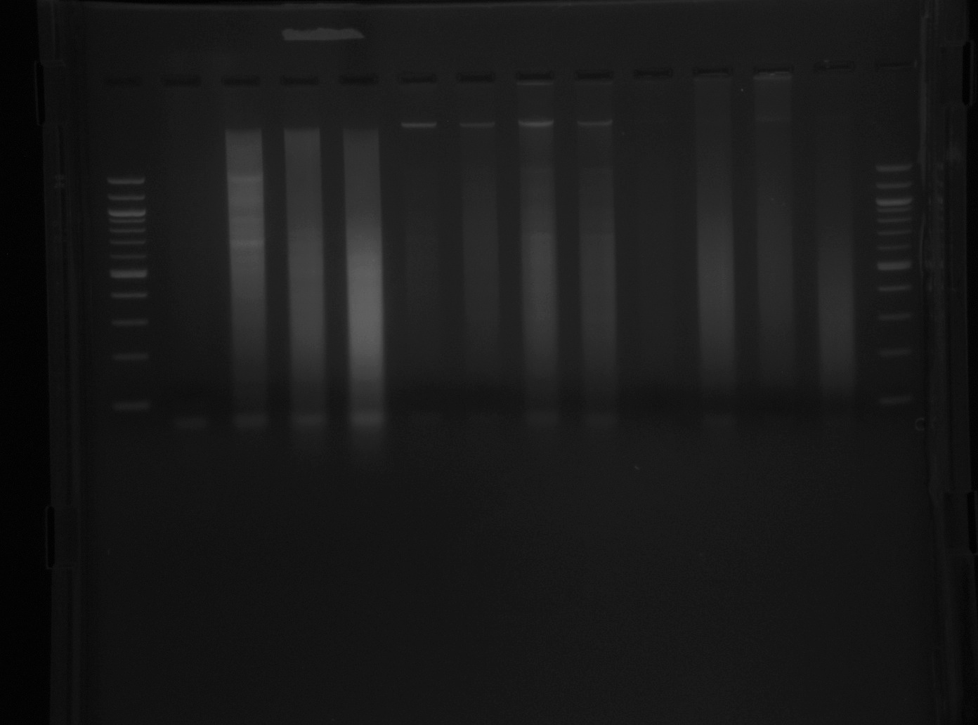
Time of
sonication
0
12
10
14
0
12
10
14
0
12
10
14
500
400
300
200
100
bp
A404
Rat SMC
Mouse SMC
500
400
300
200
100

Suggested conditions of sonication: 14min, 30s ON/30s OFF. One million cells in 120ul Lysis buffer.

